What Is the Effect of The Earth's Temperature on Cyclonic Storms?
By John Cruz
Table of Contents
What Is the Effect of The Earth's Temperature on Cyclonic Storms? 1
Introduction 1
About the Data 2
Temperature Dataset 2
Hurricane Dataset 2
Tornado Dataset 2
Global Temperatures 3
Hemispheric Temperatures 4
Hurricanes 5
Hurricanes by Hemisphere 6
Hurricanes by Category 7
Hurricanes by Temperature and Category 9
Tornadoes 10
Tornadoes by Category 11
Appendix 13
Data Sources 13

Introduction
Historical data suggests that the frequency and intensity of cyclonic storms (hurricanes, typhoons, and tornadoes) tend to increase as global temperatures rise. In this analysis, we will examine whether this relationship holds true and explore how temperature variations influence both the occurrence and strength of cyclonic storms. It is important to note that this study provides a general overview rather than an exhaustive examination of all possible factors influencing this complex relationship.

About the Data
The datasets collected for this analysis vary considerably depending on their source. To ensure consistency, this study focuses on a 25-year period (2000–2024) and examines the relationship between temperature and key characteristics of cyclonic storms. More detailed information about data sources and availability can be found in the appendix.

Temperature Dataset
The temperature data was sourced from the National Aeronautics and Space Administration (NASA). According to NASA:
“The GISS Surface Temperature Analysis version 4 (GISTEMP v4) is an estimate of global surface temperature change. Graphs and tables are updated about the 10th of every month using current data files from NOAA GHCN v4 (meteorological stations) and ERSST v5 (ocean areas).”
This dataset is particularly useful since our hurricane and tornado data were both obtained from NOAA, ensuring methodological alignment. NASA provides temperature data at both global and hemispheric scales, with monthly and annual averages available.
Because hurricane and tornado activity often varies by hemisphere, we use monthly hemispheric temperature data to capture more granular detail. The key variables of interest include hemisphere, year, month, and the corresponding temperature value.

Hurricane Dataset
The hurricane data was obtained from the National Oceanic and Atmospheric Administration (NOAA), specifically through the National Centers for Environmental Information (NCEI). This data originates from the International Best Track Archive for Climate Stewardship (IBTrACS) project, which provides comprehensive global records of tropical cyclone locations and intensities. According to NCEI:
“The data span from the 1840s to present, generally providing data at 3-hour intervals. While the best track data is focused on position and intensity (maximum sustained wind speed or minimum central pressure), other parameters are provided by some agencies (e.g., radius of maximum winds, environmental pressure, radius of hurricane force winds, etc.) and are likewise provided in IBTrACS.”
For this analysis, we use the most recent data relevant to our 2000–2024 study period, focusing on storm frequency, maximum wind speed, and storm classification by hemisphere.

Tornado Dataset
The tornado data was sourced from the National Oceanic and Atmospheric Administration (NOAA), specifically from the National Weather Service (NWS). Tornado records date back to 1950, while reports of hail and damaging wind events extend to 1955. It is important to note these tornadoes solely reside in the United States, which in turn only focuses on the Northern Hemisphere.
For our analysis, we focus solely on verified tornado tracks to simplify interpretation. Since tornadoes can cross state lines, temperature conditions may vary along their paths. Given the level of temperature granularity available, we use each tornado’s maximum intensity and state of occurrence to maintain analytical consistency.

Global Temperatures
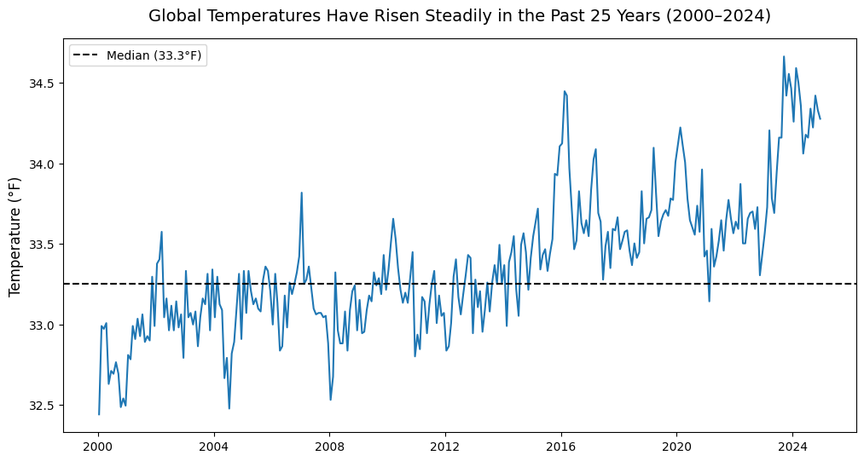

Global temperatures have risen steadily over the past 25 years. Since around 2015, temperatures have generally remained above the median of 33.3°F, highlighting a sustained warming trend.

Hemispheric Temperatures
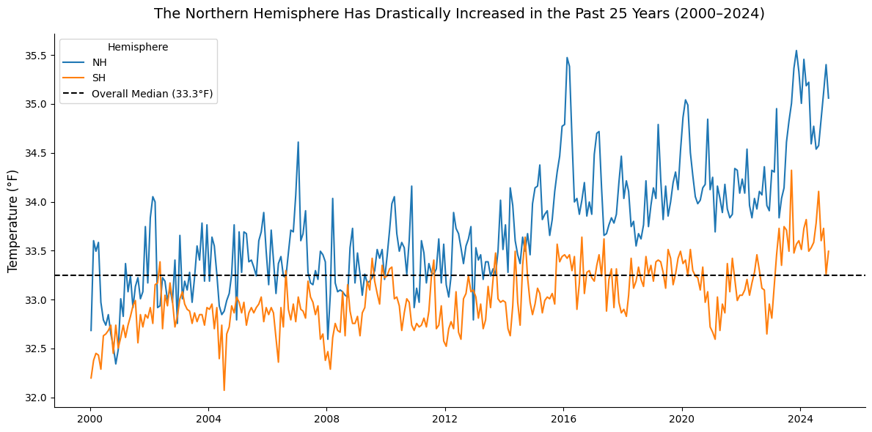

Both the Northern and Southern Hemispheres show a warming trend over the past 25 years. However, the Northern Hemisphere has experienced a much sharper increase in temperature since around 2014, while the Southern Hemisphere has remained relatively stable, staying above the overall median only since 2023.

Hurricanes
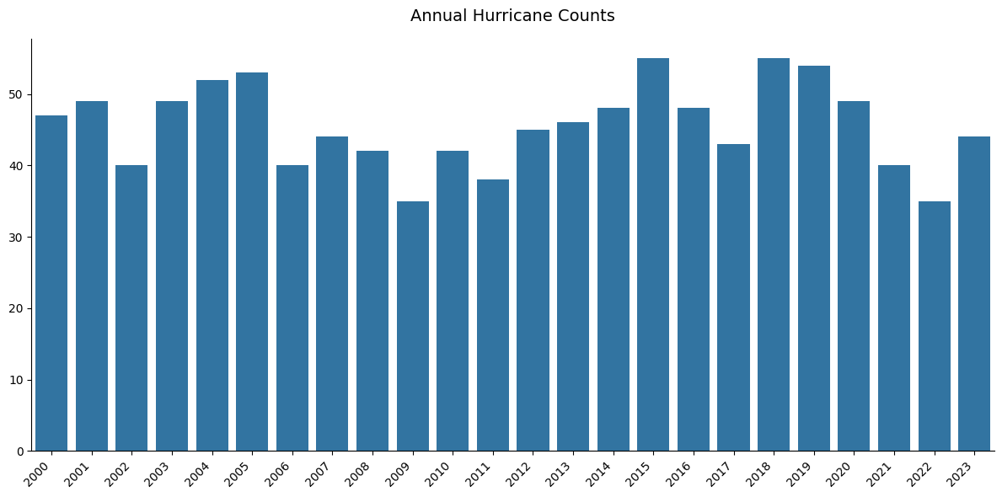

We can see that while annual counts fluctuate, there is no consistent upward or downward trend across the entire period but do have notable peaks occur around 2005, 2015, and 2019.

Hurricanes by Hemisphere
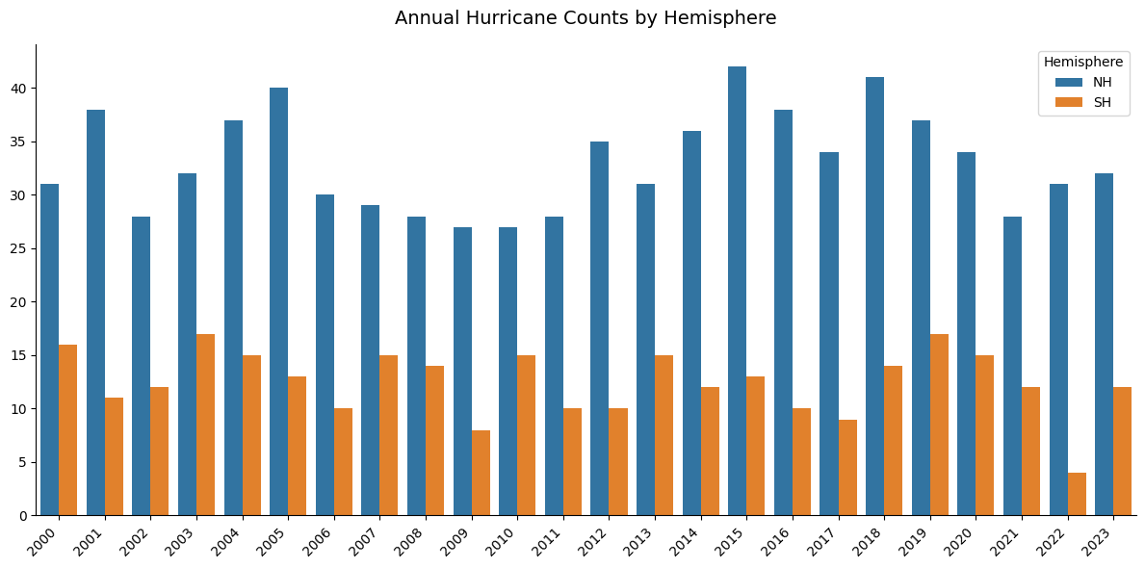

The Northern Hemisphere consistently experiences a higher number of hurricanes than the Southern Hemisphere, often accounting for more than two-thirds of total global activity. Peaks in the Northern Hemisphere, such as in 2005, 2015, and 2019, align with known periods of heightened tropical cyclone activity. While the Southern Hemisphere shows occasional variability, its hurricane counts remain relatively stable with fewer extreme fluctuations.

Hurricanes by Category
Before diving into this section, it is important to clarify how hurricanes are classified. On the Saffir–Simpson Hurricane Wind Scale, hurricanes categorized as Category 3 or higher are generally considered major. For additional information beyond the provided table, refer to the appendix section.
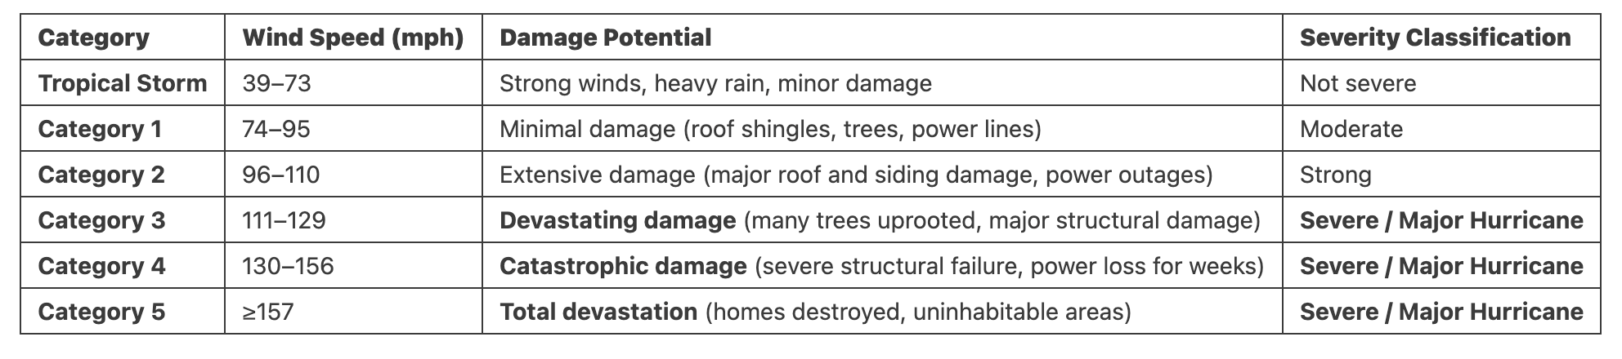
In terms of damage, NOAA explains that as a hurricane’s category increases, the damage potential is not linear.
“Since the potential damage increase from category to category is logarithmic, then small increases in wind strength can dramatically increase damage.
When the cost from hurricane-related damages are normalized (normalization takes into account inflation, changes in population, and changes in wealth to arrive at a common level for comparison), the result shows an eighth-power increase in damages from category to category.

What this means is the potential damage from a hurricane is 28. For example, a doubling of the wind speed from 75 mph (121 km/h) to 150 mph (241 km/h) does not mean a doubling or quadrupling of potential damage but 256 times increase (2 x 2 x 2 x 2 x 2 x 2 x 2 x 2=256).

This is evident in the fact that category three, four, and five storms make up only 24% of all landfalling storms, yet cause over 85% of all damages from hurricanes.”
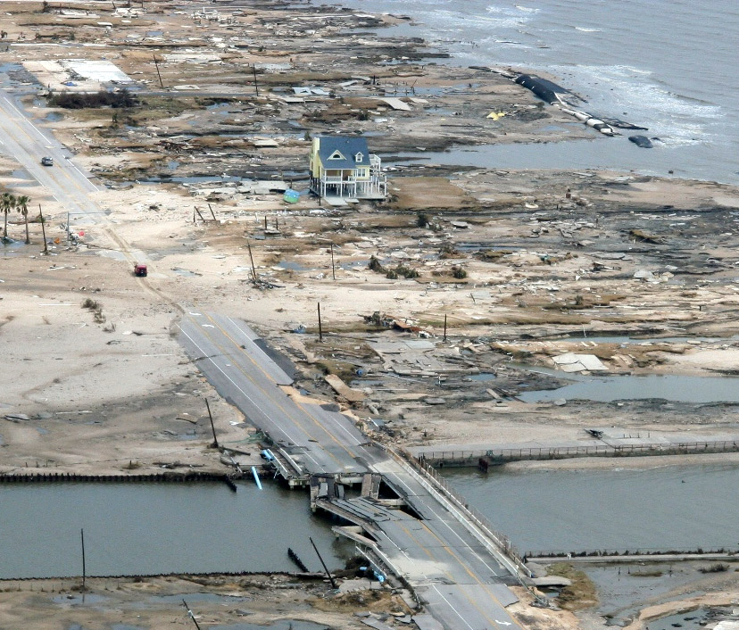

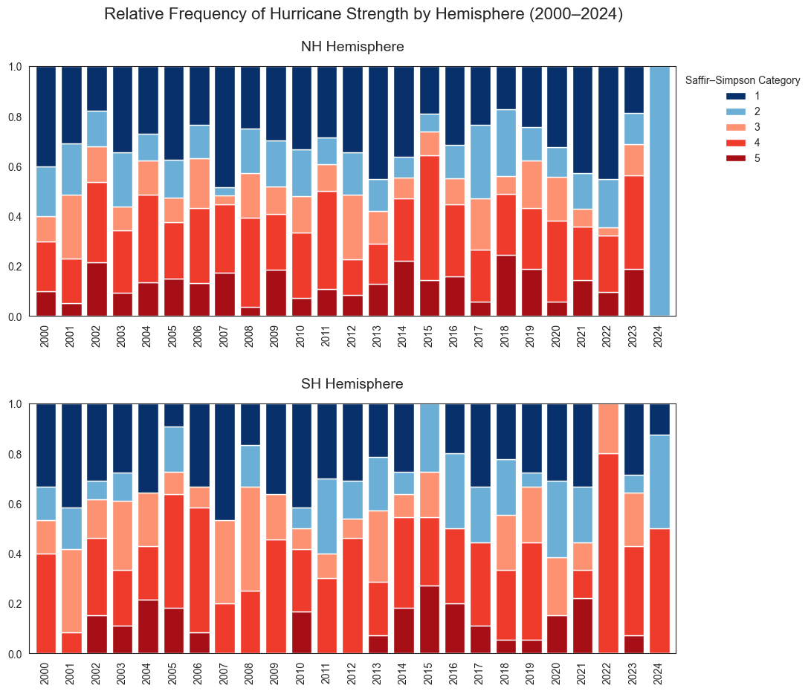

Looking at the relative frequency of major storms, we observe notable spikes in the Northern Hemisphere around 2006, 2015, and 2023, marked by higher proportions of Category 4 and 5 hurricanes. In the Southern Hemisphere, increases are evident around 2005–2006 and 2022–2023, indicating periods of elevated storm intensity.

Hurricanes by Temperature and Category
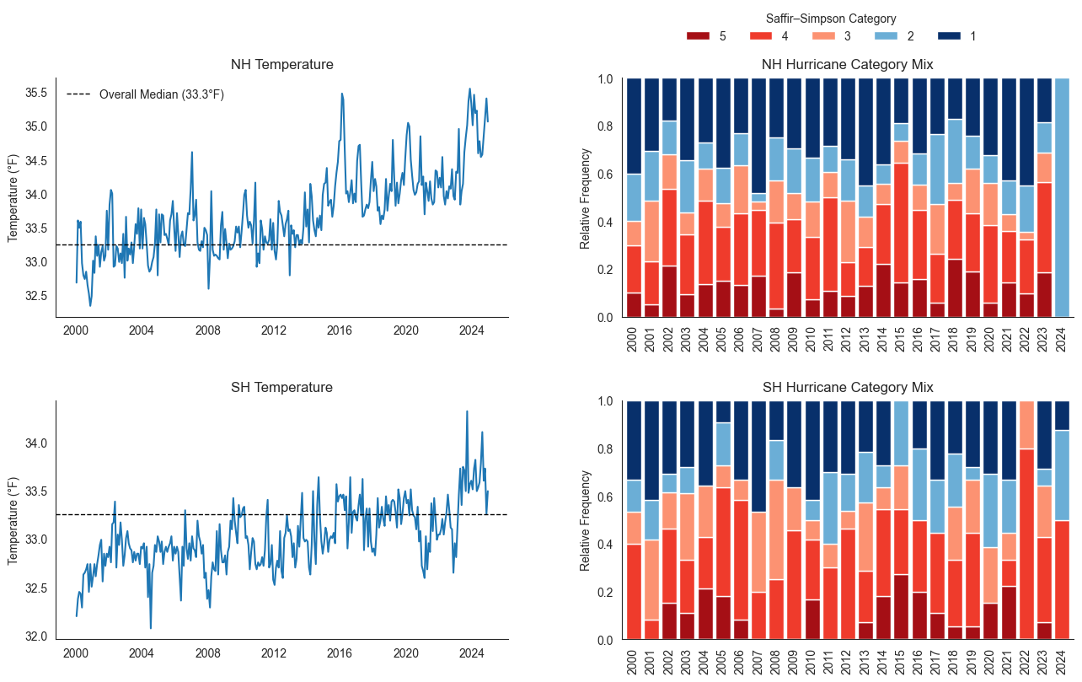
Bringing back our temperature data, we can see within the Northern Hemisphere notable peaks in both temperature and storm intensity occur around 2006, 2015, and 2023. In the Southern Hemisphere, increases in major hurricane activity are seen around 2022–2023, though the overall frequency of severe storms remains lower than in the north. Overall, the relationship suggests that periods of elevated temperature, particularly in the Northern Hemisphere, align with more frequent and intense hurricane seasons.

Tornadoes
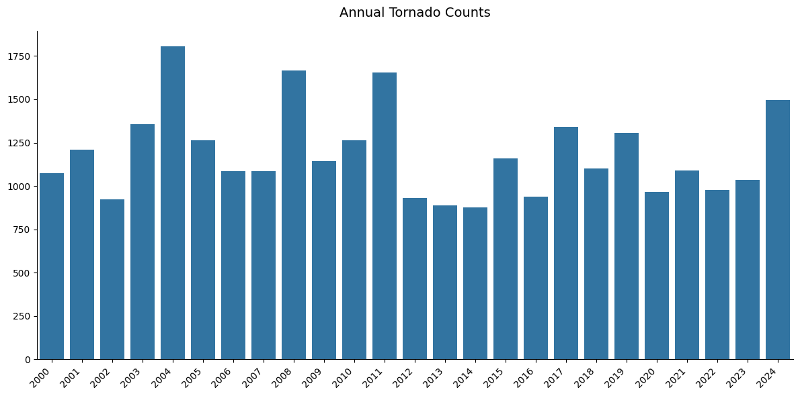

As a reminder, these tornado counts represent activity solely within the United States, which lies in the Northern Hemisphere. The annual number of tornadoes does not display a clear upward trend, even as northern hemispheric temperatures have continued to rise gradually over time. Tornado activity varies significantly from year to year, with peaks observed around 2004-2005, 2008, 2011, and 2024.

Tornadoes by Category
Again, it is important to note how tornadoes are classified. On the Enhanced Fujita (EF) Scale, tornadoes categorized as EF1 or higher begin to cause moderate damage to homes. For additional information beyond the provided table, refer to the appendix section.
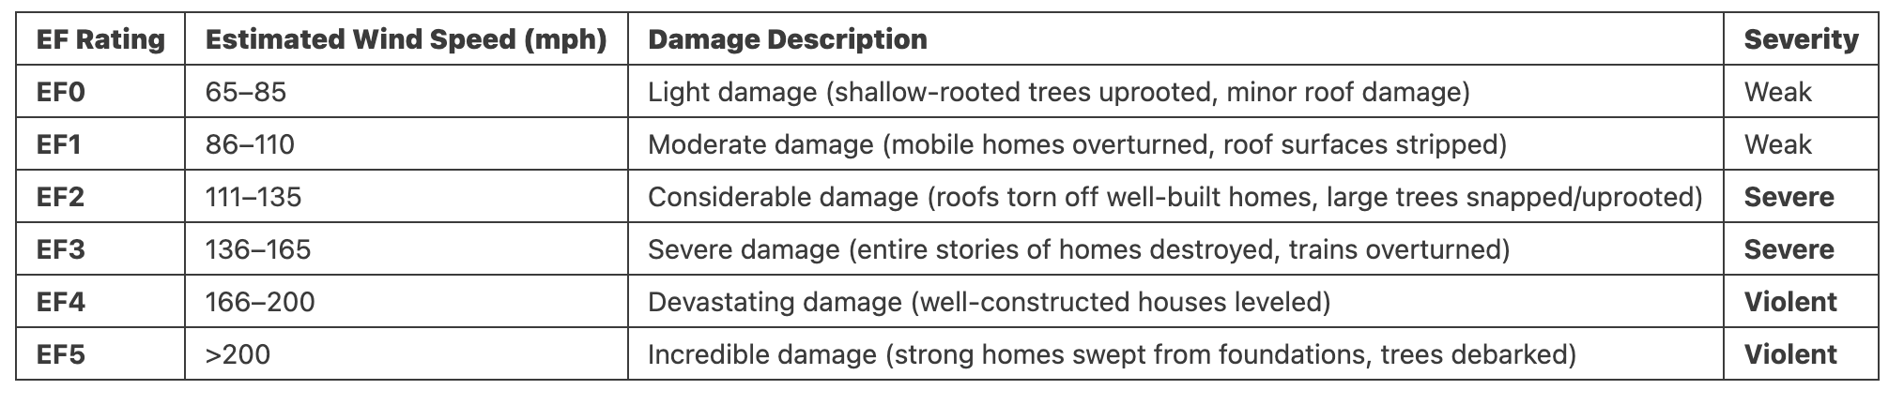
EF-0  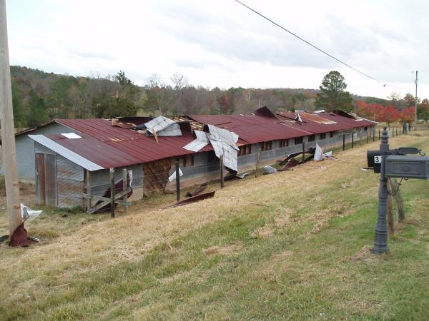 | EF-1  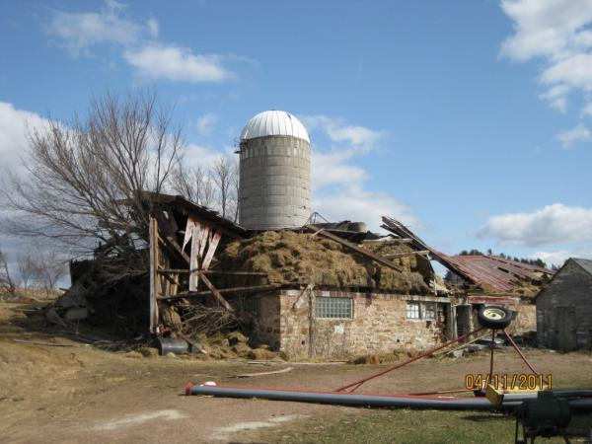 | EF-2  
EF-3  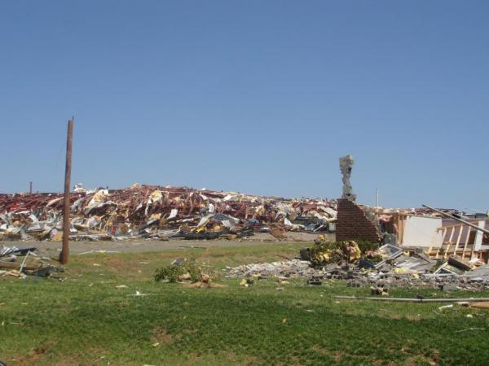 | EF-4  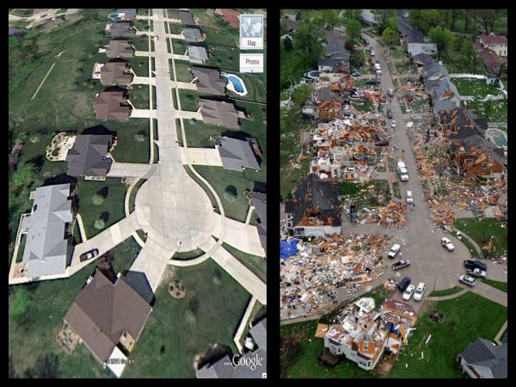 | EF-5  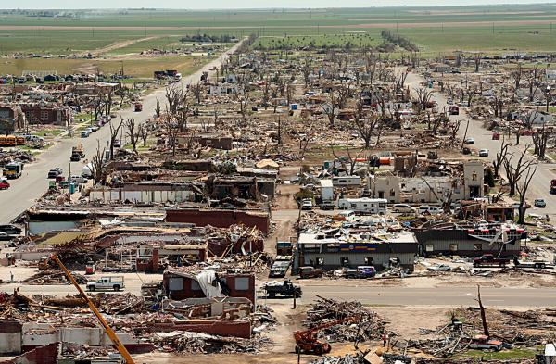

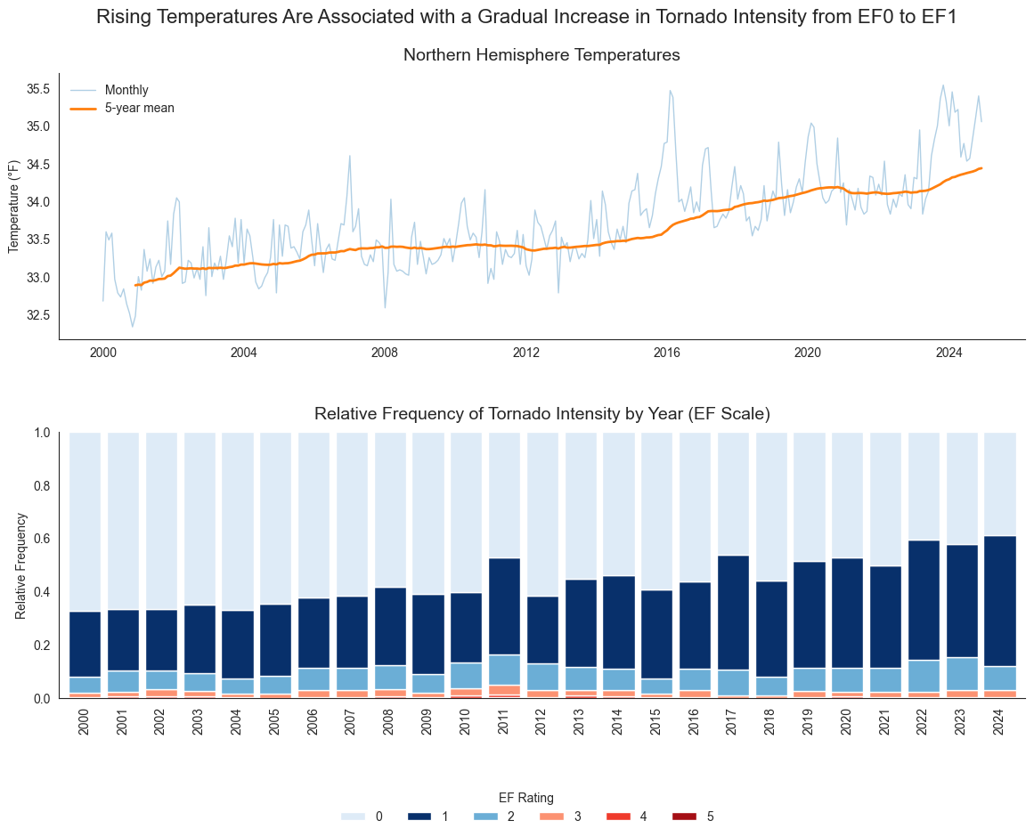
Over the past 25 years, tornadoes have shown a gradual shift toward higher Enhanced Fujita (EF) ratings, with fewer storms classified as EF0 and more falling within at least the EF1 range. Notably, the 2010–2011 period experienced a spike in more severe tornadoes, including several high-intensity events. This overall upward trend in tornado intensity aligns with the gradual rise in Northern Hemisphere temperatures, suggesting a potential connection between warming conditions and increased storm strength.

Appendix

Data Sources

Temperatures (NASA)

Hurricanes (NOAA)
- Data Dictionary
- About the Data
- Hurricane Categories
- Damage
- The hurricane data was available via public datasets stored on Google BigQuery. A simple SQL query was needed to obtain the data extract.
SELECT
season,
sid,
basin,
latitude,
longitude,
iso_time,
usa_sshs,
usa_wind
FROM `bigquery-public-data.noaa_hurricanes.hurricanes`
WHERE season BETWEEN '1989' AND '2025'

Tornadoes (NOAA)
- Data Dictionary
- Damages

